Dear Parents/Carers

Rendlesham Nursery has a snack charge for all funded sessions.
.
The cost for snacks is 60p per session. Please see example below:

15 hours funded (5 sessions) at £3.00 per week
21 hours funded (7 sessions) at £4.20 per week
30 hours funded (10 sessions) at £6.00 per week

Snacks will be invoiced half termly, and payment will need to be paid on the Arbor App.
If payment is not received, you will need to provide snack until your account has been cleared.

This is not compulsory, and you have the option to opt out. Should you decide to opt out you will need to provide snacks for your child for the week.

All snacks will need to be brought into the nursery on the first session of each week and handed to a member of staff.

If snacks are not brought in for the week a charge will be added and invoiced.

The nursery will only accept healthy snacks; a list of all acceptable snacks can be found attached. You will need to provide enough snacks for the week; this will vary based on the number of funded hours your child attends.

Kind Regards
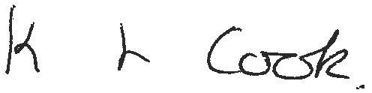

Kirsty Cook
EYFS Lead/Assistant Academy Head

Please confirm option using the slip below
I wish/do not wish to pay for snack each week for __________________ my child
attends _________ funded hours a week.

I wish to opt out of snack charges and confirm I will bring in snack as listed for
____________________each week.
Parents/carer name:
________________________________
Parent/carer signature:
_________________________________

Snacks accepted
15 hour funded sessions please provide a bag of one of the fruits below and a packet/bag of the snacks listed below each week
30 hour funded sessions please provide 2 bags of the fruit
List of snacks
Melon Satsumas Pears
Apples Bananas Oranges
Cheese Straws Crackers Rice Cakes
Breadsticks

